**Predicted Distribution of *Eragrostis tef* in present vs. 2050**

By Judith Tijm s1252143

In this study an attempt is made to predict the distribution of teff (*Eragrostis tef)* in the year 2050. Teff is a plant that belongs to the family Poaceae and is one of the approximately 350 species within the genus of Eragrostis, also known as love grass. It is an important staple grain in Ethiopia and Eritrea, where it has been cultivated for at least 2000 years (D’Andrea, 2008). Teff has several benefits over other cereals: the seeds are free from gluten, resistant to storage pests and teff is more tolerant to extreme environmental conditions (Assefa et al., 2015). Even though teff originated in the Horn of Africa, this grass species is now growing on almost every continent. In the United States and Australia teff is cultivated for the production of cattle feed and in Denmark, France and South Africa it is recorded as introduced.

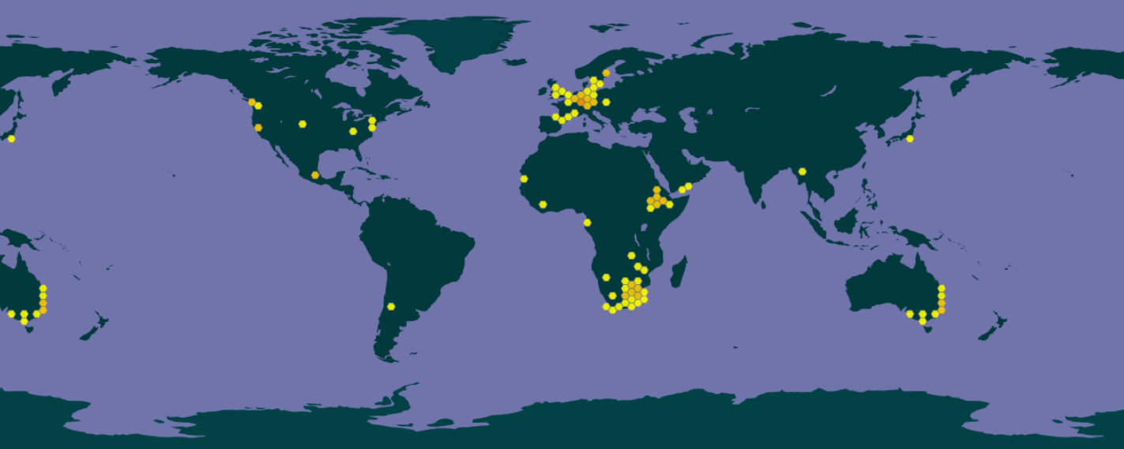

***Figure 1*** *Distribution of E. tef (GBIF)*

Teff is mainly present in the temperate zones of the earth. Occurrences of the species seems higher in coastal areas, suggesting a higher suitability in an oceanic or maritime climate. This type of climate is characterized by mild winters and warm summers, with moderate to high rainfall during the whole year.

Methodology

Occurrence data were downloaded from GBIF[1]. Figure 1 shows the georeferenced records (n=427) in GBIF. Climate variables were downloaded from WorldClim 1.4: current and future bioclimatic variables both at 5 minute resolution. For the future bioclimatic variables climate model HadGEM2-AO has been selected with Representative Concentration Pathway (RCP) 6.0. According to this scenario the temperature will rise with 1.3 degrees in the period from 2046 to 2065. In RStudio correlation tests have been performed to check for highly correlated bioclimatic variables (cor >= 0.7, cor <=-0.7). The variables that were selected after testing were BIO1 (Annual Mean Temperature), BIO12 (Annual Precipitation) and BIO15 (Precipitation Seasonality). As the distribution of *E. tef* widespread, the more general variables were selected.

MaxEnt was used to make prediction models of the species distribution for the present and future climate. The ‘Random test percentage’ was set to 0 and ‘Max number of background points’ to 10 000.

Model Output

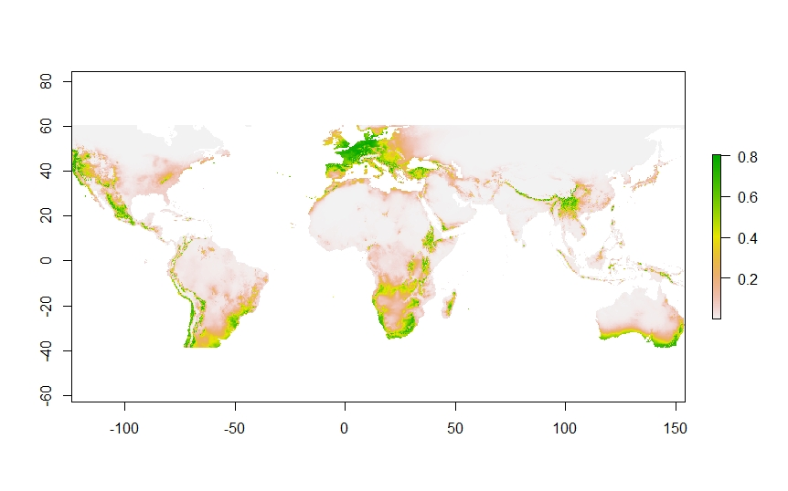

***Figure 2*** *Habitat suitability prediction based on current bioclimatic variables*

In figure 2 the predicted distribution based on current climate data is shown. This predicted distribution map is highly similar to the GBIF georeferenced records map (fig. 1) with some expansion among the coastal areas of the southern hemisphere.

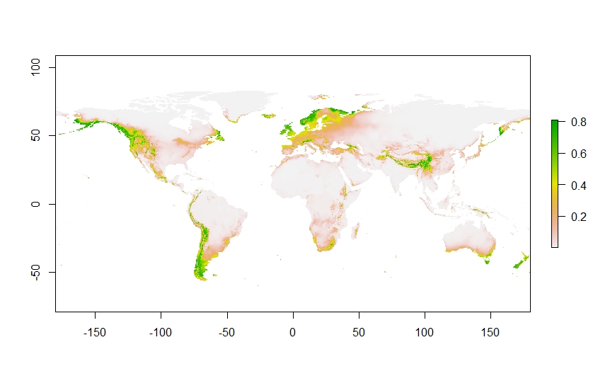

***Figure 3*** *Habitat suitability prediction based on future (2050) bioclimatic variables*

Figure 3 gives the predicted distribution in 2050. In this scenario it is predicted that the distribution of *E. tef* will move away from the equator towards the polar regions: in middle Europe the occurrence of teff is predicted to dramatically decrease but seems to increase in the northern Scandinavian regions. In South Africa and Australia the distribution of teff is driven to the uttermost southern regions. It also seems that in this map the grass is doing well in the mountain ranges of the Andes, the Himalaya and the Alpes. In figure 4 this extreme shift is presented in a clear way.

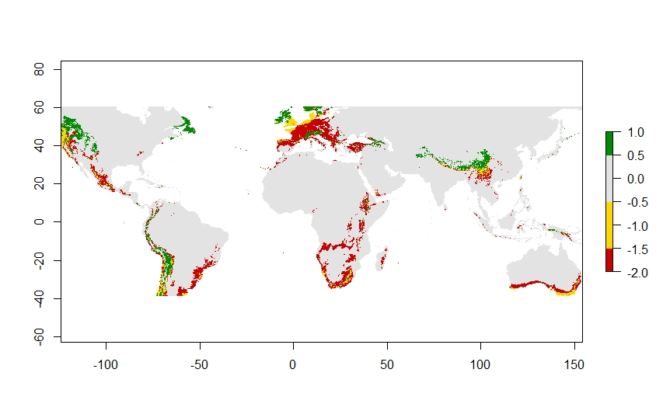

***Figure 4*** *Response of future scenario. Yellow indicates areas that remain suitable, red indicates areas that lose their suitability and green indicates areas that gain suitability, grey is never suitable.*

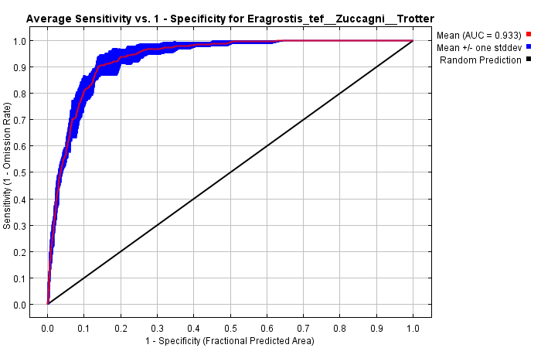

***Figure 5*** *The ROC curve for E. tef with AUC = 0.993 (sd=0.011)*

In figure 5 is the sensitivity (or True Positive Rate) plotted against 1-Specificity (or the False Positive Rate) for all possible classification thresholds which range from 0 to 1. With an AUC of 0.933 (sd = 0.011) this model has a high predictive power.

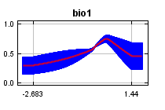 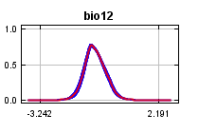  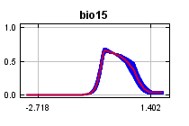

***Figure 6*** *Response curves of bioclimatic variables*

The climatic variables that were selected for this model were BIO1, BIO12 and BIO15. The response of *E. tef* to the different variables are visualized in the curves of figure 6. It is clearly visible that the variables concerning precipitation have an effect on the predicted environmental suitability of teff. Both response curves show a peak. The response curve of BIO1 has a slight, but not convincing optimum and is probably not the most useful variable for making prediction models. Also table 1 shows that BIO1 has a low relative contribution compared to the other environmental variables.

|  |  |  |
| --- | --- | --- |
| Environmental Variable | | Contribution % |
| BIO1 | Annual Mean Temperature | 11.7 |
| BIO12 | Annual Precipitation | 47.3 |
| BIO15 | Precipitation Seasonality (Coefficient of Variation) | 41 |

***Table 1*** *Contribution of the environmental variables*

Biological interpretation

Even though not the most rosy scenario was picked for this model, the shift in suitable habitat for teff in the coming 30 years is more extreme than expected. According to this model the places where teff is currently cultivated will lose their suitability in the coming decades. Should Ethiopian farmers move to the Himalaya in order to keep cultivating their beloved and nutritious cereals? Probably not. Should the writer of this report improve their model? Probably!

First of all, the model is based on only three variables. The environmental variable concerning temperature also has a low contribution, which means that most of this model is based on precipitation data. Even though these data are important to take into account for future scenarios as climate change will influence precipitation patterns will change, it is not enough to build a complete model. In hindsight other temperature variable could have been more useful, e.g. BIO4 (Temperature Seasonality) since most *E. tef* grows in regions with seasons (which means that the mean temperature does not give a lot of information).

Second, in this model biotic climatic variables and geographical blockades are not taken into account. However, because teff is wind pollinated and is not a very demanding plant, a model with the right abiotic factors good probably give a good estimation of the future distribution of this species of love grass.

Assefa et al. (2015) Genetic diversity in tef [Eragrostis tef (Zucc.) Trotter] Front. Plant Sci., 26 March 2015 | https://doi.org/10.3389/fpls.2015.00177

D’Andrea, A.C. Econ Bot (2008) T’ef (Eragrostis tef) in Ancient Agricultural Systems of Highland Ethiopia 62: 547. <https://doi.org/10.1007/s12231-008-9053-4>

<https://github.com/judithtijm/mebioda/tree/master/data/s1252143>

upload files

1. GBIF.org (6th December 2018) GBIF Occurrence. Download <https://doi.org/10.15468/dl.lyqquc>.